2017-04-12

Bryan Greener

Chad Hirsch

Jason Gunderson

Workshop Ch12

12.39

**a)**

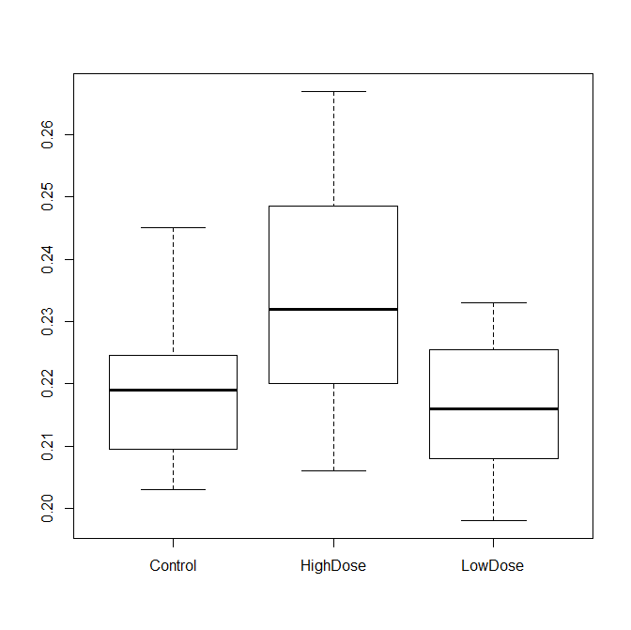

Means

Control HighDose LowDose

0.2188667 0.2350667 0.2159333

This boxplot is showing that both the control and LowDose values have similar means and less range of values. The HighDose set has a wider range of values and a higher mean BMD.

**b)**

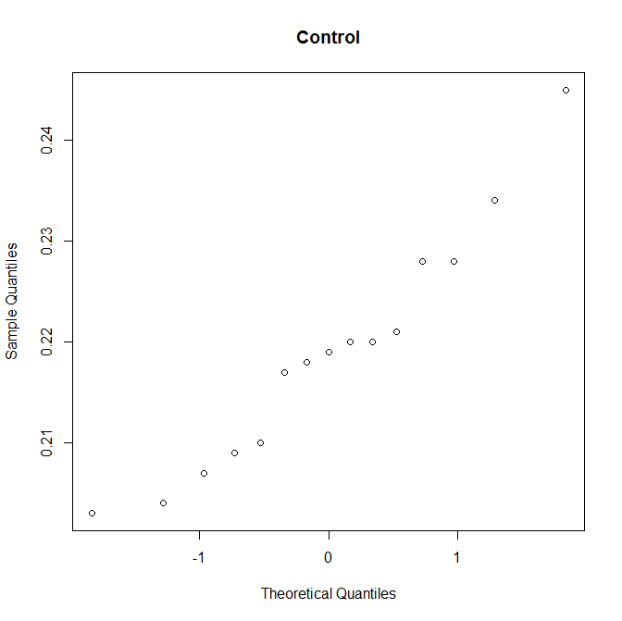

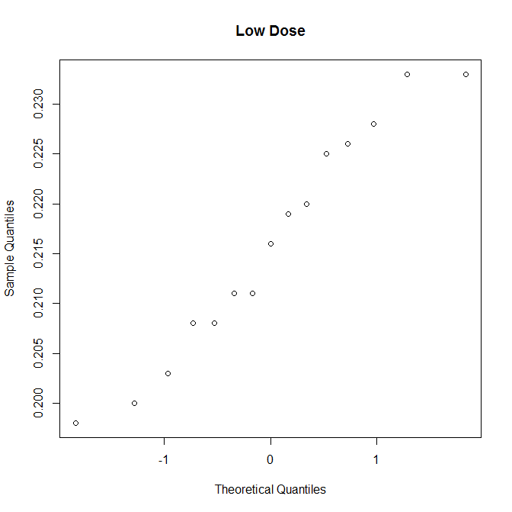

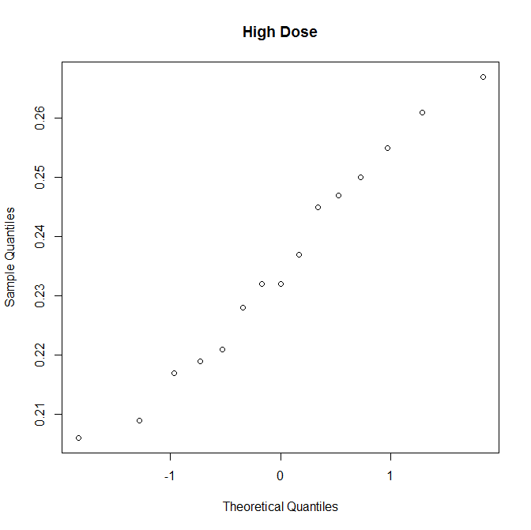

Mean

Control HighDose LowDose

0.2188667 0.2350667 0.2159333

SD

Control HighDose LowDose

0.01158735 0.01877105 0.01151066

**c)**

Analysis of Variance Table

Response: BMD

Df Sum Sq Mean Sq F value Pr(>F)

Treatment 2 0.0031856 0.00159282 7.7182 0.001397 **

Residuals 42 0.0086676 0.00020637

---

Signif. codes: 0 ‘***’ 0.001 ‘**’ 0.01 ‘*’ 0.05 ‘.’ 0.1 ‘ ’ 1

**d)**

BMD and Treatment

Control HighDose

HighDose 0.0107 -

LowDose 1.0000 0.0022

P value adjustment method: Bonferroni

**e)**

Based on the results from parts c and d, the p values suggest that the high dosage of Isoflavones have a significant effect on the bone marrow density of the femurs of the rats. However, a low dose does not show much effect on the bone densities.

Data

data=read.csv("kudzu.csv")

fix(data)

attach(data

# A

boxplot(BMD~Treatment,data)

# B

sapply(split(BMD,Treatment),"mean")

sapply(split(BMD,Treatment),"sd")

# C

model=lm(BMD~Treatment)

anova(model)

# D

pairwise.t.test(BMD, Treatment, p.adjust="bonferroni")

detach(data)